**SEA2004F Test – Friday 9th June 2017**

**A.Prof Isabelle Ansorge section**

**[5 marks each]**

1. What are the characteristics of the Somali Current in terms of speed, ocean structure (depth/width) and direction. Why does this current reverse?
2. Where would you find the Cromwell Current?
3. Describe the atmospheric circulation associated with a Polar Cell. How does it compare to the Hadley Cell?

**[10 marks each]**

1. Draw a schematic diagram of a section across the equatorial Pacific that depicts the structure of the winds, and the circulation and depth thermocline in the upper ocean.
2. 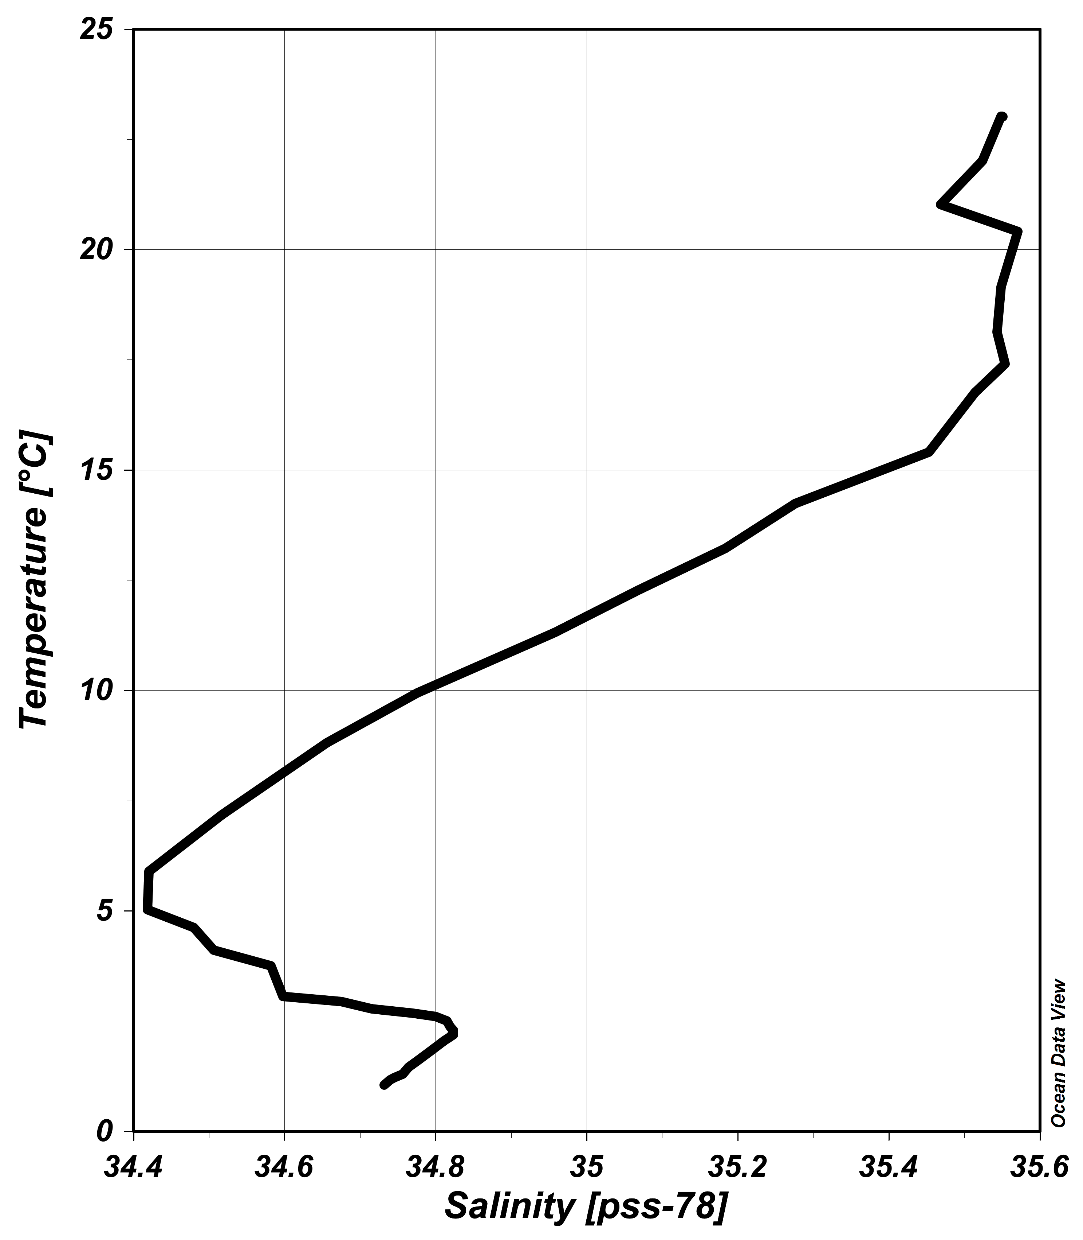Explain with a diagram how you would expect the mixed layer depth to vary across the Pacific Ocean during a La Nina event. How do these profiles differ from an El Nino?
3. Using the figure to the right identify (provide names) on the figure the main water masses associated with surface, intermediate, deep and bottom waters.

**Dr Sarah Fawcett section**

1. Define the following [*2 marks each; 10 marks total*]:

1. Solubility pump
2. Nitrification
3. HNLC regions
4. Carbonate compensation depth
5. Martin curve

2. The Marine Carbonate System [*18 marks total*]

1. Write an equation that describes i) DIC and ii) Total Alkalinity [*2 marks*]
2. How do each of the processes listed below affect DIC and Total Alkalinity (i.e., increase, decrease, no effect)? Briefly explain the reason for the change or lack of change (*hint*: use the equations from (a) to help you) [*12 marks*]
3. CaCO3(s) dissolution
4. Remineralization
5. Outgassing of CO2 from the ocean to the atmosphere
6. With the aid of a sketch, explain the role of the ocean’s biological carbon pump in controlling the atmospheric CO2 concentration [*4 marks*]

3. Nutrients and stoichiometry [*12 marks total*]

1. Below is the equation for photosynthesis/remineralization (i.e., the two processes are described by the same equation, operating in different directions). Wherever you see _____, fill in the missing Redfield ratio coefficient for carbon, nitrogen, phosphorus and oxygen. Note that on the right hand side of the equation, the species in bold and in brackets is organic matter/biomass [*3 marks*]

____CO2 + HNO3 + H3PO4 + 78 H2O ↔ (**C**___**H175O42N**___**P**___ ) + ____O2

1. On a sampling trip to the middle of the subtropical South Atlantic, you measure the following NO3- and PO43- concentrations in the waters below the euphotic zone:

|  |  |  |  |
| --- | --- | --- | --- |
| Depth (m) | NO3- (μmol/kg) | PO43- (μmol/kg) | NO3-/PO43- |
| 120 | 2.0 | 0.10 |  |
| 150 | 2.5 | 0.12 |  |
| 200 | 4.0 | 0.22 |  |
| 250 | 7.3 | 0.40 |  |
| 300 | 9.4 | 0.52 |  |

1. On the axes provided below, plot the measured NO3- concentration on the x-axis and the AOU concentration that you expect to correspond with the NO3- concentration on the y-axis. What is the slope of the linear relationship between AOU and NO3-? [*3 marks*]

Macintosh HD:Users:sarahfawcett:Desktop:Axes.eps

1. Calculate the ratio of NO3- to PO43- for the data given above and enter it into the Table. Is the ratio higher than, lower than, or equal to your expectations for ocean waters? If there is a deviation from expectations, name the biological process responsible and explain how this processes changes the NO3- to PO43- ratio? [*4 marks*]
2. What is the average iron concentration in the open ocean? Name three sources of iron to ocean waters [*2 marks*]